

Practices for Secure Software Report

Table of Contents
Document Revision History 3
Client 3
Instructions 3
Developer 4
1. Algorithm Cipher 4
2. Certificate Generation 4
3. Deploy Cipher 4
4. Secure Communications 4
5. Secondary Testing 4
6. Functional Testing 4
7. Summary 4
8. Industry Standard Best Practices 4

Document Revision History

Version | Date | Author | Comments
1.0 | 10/18/26 | John O’Brien

Client



Instructions

Submit this completed practices for secure software report. Replace the bracketed text with the relevant information. You must document your process for writing secure communications and refactoring code that complies with software security testing protocols.

- Respond to the steps outlined below and include your findings.
- Respond using your own words. You may also choose to include images or supporting materials. If you include them, make certain to insert them in all the relevant locations in the document.
- Refer to the Project Two Guidelines and Rubric for more detailed instructions about each section of the template.

Developer
John O’Brien

Algorithm Cipher

The industry standard algorithm cipher for end-to-end encryption is AES-256. AES is an algorithm that uses a secret key as a set of instructions. It then breaks the data up into small pieces and is used to form a series of shuffles. This turns the data into unreadable noise. To recreate the data, the same sequence of shuffles would need to be performed in reverse.
The 256 part of the cipher is a reference to the size of the key. The larger the key space, the more steps required to encrypt or decrypt the transmission. The amount of computation required to discover the correct sequence to unshuffled the data would take current computers many billions of years with brute force methods.
AES is a symmetric algorithm, meaning it uses the same key to decrypt as to encrypt. While this may sound less secure, the advantages aren’t just speed. For one, moving away from older, large prime based algorithms is required for post-quantum security. While quantum computing isn’t present now, malicious actors may record your encrypted data now, and then later use quantum computation to decrypt your data if it uses older encryption algorithms. For another, modern encryption protocols, like TLS 1.3, use a process by which both ends of the transmission separately derive the same key without ever transmitting that key. This is the latest security standard, and necessarily requires symmetric encryption.
Finally, since AES-256 has become so industry standard, modern processer chips are hard manufactured to efficiently perform the necessary computations, making AES-256 far faster than any other current algorithm.

Certificate Generation
Insert a screenshot below of the CER file.

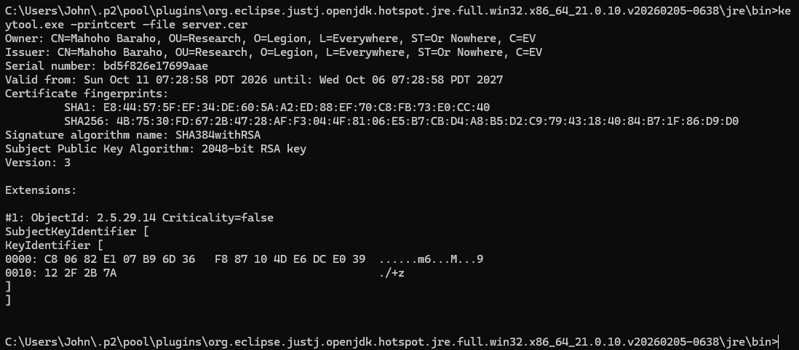

Above is a screenshot of a self-signed certificate. The certificate is like a signature that contains its SHA-256 hash value. Any changes to the name, organization, or key information would change the SHA-256 hash value, and therefore the signature is functionally unfakeable. Because it is only self-signed, however, the certificate is only as trusted as the individual who signed it. Artemis Foundation will want to use certificates signed by a Certificate Authority so that it is viewed as trusted on all modern browsers.

Deploy Cipher
Insert a screenshot below of the checksum verification.

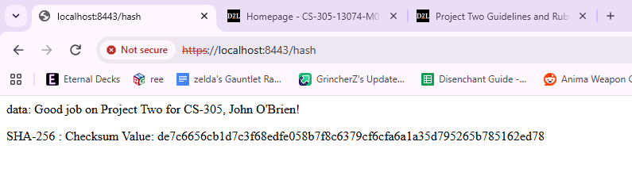
Above is shown a visual representation of how a cipher works. The text, “Good job on Project Two for CS-305, John O’Brien!” is run through the SHA-256 hashing algorithm. That produces a lengthy check sum. If any part of the text is changed, a different check sum is generated. The odds of this being a matching check sum are infinitesimally small.

Secure Communications
Insert a screenshot below of the web browser that shows a secure webpage.

Using the same screenshot, you can also see in the address bar the fact that https was utilized in accessing the communication. Because the browser does not trust the self-signed certificate, the https is crossed out and it is displaying a “Not secure” notification. This is why Artemis Foundation will want to have a certificate that is signed by a recognized Certificate Authority.

Secondary Testing
Insert screenshots below of the refactored code executed without errors and the dependency-check report.

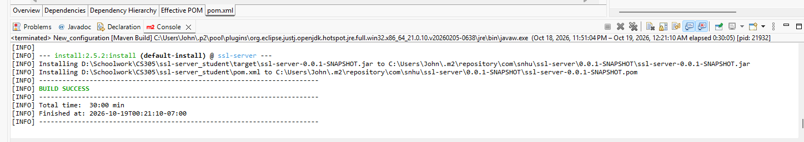

Above is a screenshot showing that the build successfully compiled without error. This ensures the code has no compile-time errors. That means that Java did not notice any obvious errors, like broken syntax. It does not ensure that the code has no errors. The software may tell Java to do something that seems reasonable, but could fail for other reasons, like if a function is fed a different type of value than it was expecting. This is called a run-time error.

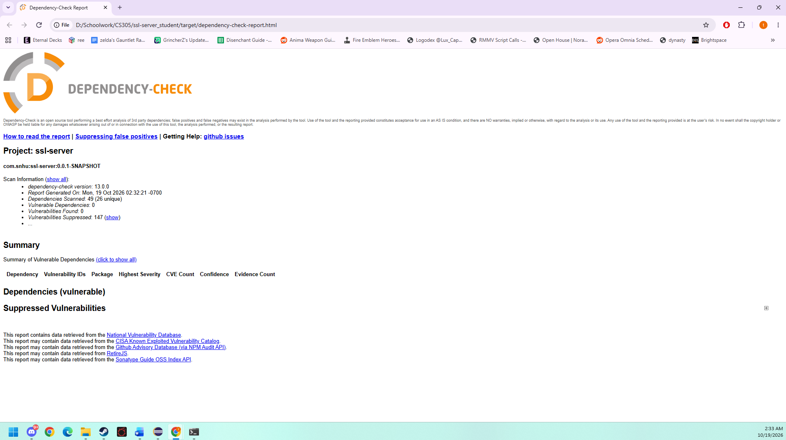

Above is a screenshot of a dependency check. Java coding uses many open source libraries to minimize repetition of work. These are updated regularly as security vulnerabilities are found. A dependency check informs the programmer if there are any known security vulnerabilities in their current libraries, and if there is already an update for those dependencies to fix that vulnerability.

Functional Testing
Insert a screenshot below of the refactored code executed without errors.

- Syntactical: Syntax errors are caught by the compiler when the programmer attempts to compile the code. If the code successfully builds, it does not have any syntax errors. The code should still be manually reviewed by programmers to ensure the syntax doesn’t just not create an error, but also communicates its intended purpose.

- Logical: Logical errors can either cause during runtime or produce incorrect results. As shown in previous screenshots, the code produced the desired output when run. See below, a screenshot showing the console not producing any errors when the program was executed or when a user accessed the website. The code should still be manually reviewed for possible edge cases or errors that could produce undesired results. Automated test cases are also used in larger applications.

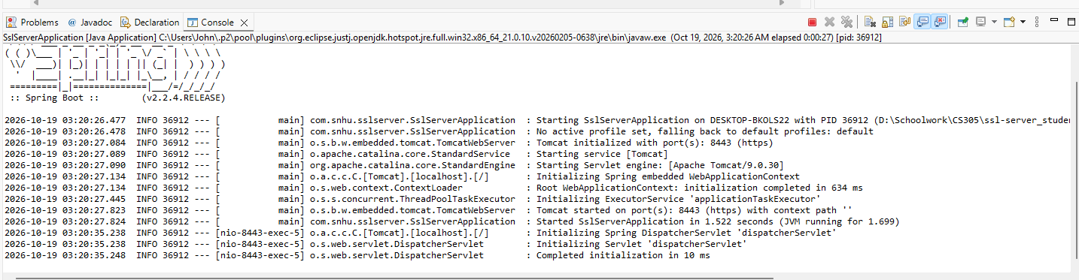

- Security vulnerabilities: Security vulnerabilities can come either from vulnerabilities inside dependencies or from not following best-practices secure patterns. As shown previously, the dependency check successfully ran without communicating any vulnerabilities. This doesn’t necessarily mean the code is secure. A programmer should also review the code, particularly focused on places where data moves in or out of the system, and between different parts of the system.

Summary

In this program, the encryption is entirely being handled by dependencies, invisible within the Java files. Spring Boot loads up a Tomcat virtual server. A configuration file has been edited to make Tomcat use a secure port and to use a self-signed certificate to encrypt traffic via an SSL keystore.
When reviewing the code to ensure it is secure, I use the vulnerability assessment process flow. This has you look through various aspects of the code and ensure proper secure patterns have been followed.
- Input Validation: Here, the text has been manually hard coded into the application. In a situation where the message is being taken as input, the code should parameterize the input to ensure it is of the appropriate type and form.
- APIs: This is where you review the API endpoints in the system. Open API endpoints are the biggest vulnerable locations for web applications, though you should also review where your application accesses other APIs, as that can also be a security vulnerability. In this application, we do not access any external APIs, and our only API endpoint is intended to be a public facing page that has no access to the rest of the system.
- Cryptography: This is where you ensure your application is encrypting any data that is intended to be encrypted. Many websites are not intended to be encrypted, as they are public websites that do not track user information. Other websites, or even other parts of the same website, may involve users inputting usernames and passwords, updating their profile, or any number of other pieces of information that should be encrypted. This program successfully uses an SSL keystone to encrypt data in transit via HTTPS.
- Client / Server: During this part of review, you should have a focus on what parts of the process are taking place on the client’s machine, what parts of the process are taking place on the server’s machine, and perhaps most importantly when and how data is transmitted between these two components. These are some significant areas of security vulnerability, as poor security patterns can treat these transmissions as though they are within the system. In this case, the client sends a request to the server to GET the desired string, and the server sends that string to the client. The client never gets access to the system, and the server only sends information it is intended to send, and so this is secure.
- Code Error: Here, the programmer reviews what happens if the code produces errors. Encrypting information is only one part of modern cybersecurity. Some malicious actors may not wish to gain access to information but simply to disrupt your services by straining or crashing your machine. If the code generates an error it is not programmed to handle, this can force the system to generate complex logs. A common form of Denial of Service attack is to send thousands of requests that produce an error at the same time. This application uses a try block when calling MessageDigest. If the try block fails, a catch block catches that error to ensure the application doesn’t fail.
- Encapsulation: Here, the programmer should review the classes that make up their system and ensure those can only be accessed or altered in approved ways. This application only utilizes one class, a controller, with a single accessible endpoint. In more complicated applications, encapsulation should be used to ensure the system can only be accessed through Controllers via approved API endpoints, and that from those API endpoints they only have access to parts of the system needed for their transaction.

Industry Standard Best Practices

I followed several best practices when creating this application. By using @RequestMapping(“/hash”), all transmissions to this address are run through this block of code, ignoring any commands the client may have requested. A string variable is initiated as “”, to ensure no error is thrown if that variable fails to get populated. A try block is used to ensure the application doesn’t throw errors.
Additionally, most of the application is present in the Java dependency libraries. Running regular dependency checks ensures I am aware of any known vulnerabilities buried in the code behind my code. Tomcat was the source of a particularly dangerous vulnerability several years ago. Then, Tomcat was used to deploy virtual servers and massive, critical vulnerabilities were found in this process. Current best practices are to load the application directly through Java. Java then creates a container and deploys a virtual server within that container via Tomcat. I have also modified the Tomcat configuration file to ensure that Tomcat uses my desired port, HTTPS communication, and the SSL keystone associated with my system’s certificate.
Industry best standards are constantly updating to respond to increasing sophistication from malicious actors. Proper security can protect your system from attack. If your application stores user personal or financial information, it is necessary to prevent substantial fines and to avoid public backlash from a leak. This is particularly important to Artemis Financial, as financial advisors are required to have additional security protocols for compliance.
The biggest dangers of not following industry standard best practices are remote execution of code and malicious applications. Even if you think your application isn’t complicated enough to give attackers access to your system as a whole, you may be wrong. If your application takes string inputs from clients, these strings can be embedded with commands. If these strings are called in particular ways, it may mistakenly send commands to the system and allow the attacker to run commands from the system. In many situations, this is used to download ransomware that can cost the company millions of dollars if they do not want to lose access to their entire system and give the attacker all of their encrypted data.

